
Ghana Communication Technology University
Faculty of Engineering
Department of Computer Engineering
Level 300
Industrial Internship

FOREST RESERVE MONITORING SYSTEM PROTOTYPE

Author: Ernest Etornam Adeti
Author: Benedict Mawusenam Amaglo

Institution’s Endorsement

ACKNOWLEDGEMENT
I will like to express my sincere gratitude to the dedicated staff of the Forestry Commission for their kind gesture of reviewing this mini project and giving us the necessary remarks.

Introduction 1
PROJECT OVERVIEW 2
OBJECTIVES 3
COMPONENTS USED 4
SCHEMATIC 5
LIMITATIONS OF THE SYSTEM AND SOLUTIONS 6
CONCLUSION 7

PAGE INTENTIONALLY LEFT BLANK

Introduction
As part of the computer Engineering curriculum, students are required to embark on an industrial internship with the aim of giving them the exposure to build their skills set and solve problems that today’s society faces.
In the quest of fulfilling this requirement of the curriculum we decided to build a project that monitors every activity that occurs in the Forest reserves without Forest guards being present all the time to monitor such occurrences as their lives are usually at stake especially during late night periods.

PROJECT OVERVIEW
The project incorporates a Microcontroller board, sensors, Artificial Intelligence and GSM modules which provide remote messages indicating alerts of intrusion, fire, or lumbering.
Unfortunately, the short period for which the internship is supposed to take place, as well as issues of financial constraints, we had to build a prototype of this project which uses a less powerful but affordable microcontroller board and sensors which cannot incorporate Artificial Intelligence.

OBJECTIVES
- To detect human presence using a PIR motion sensor and an ultrasonic sensor, as against the main idea of using artificial intelligence (Computer Vision) for human presence detection
- To identify potential fire hazards using a flame sensor.
- To detect chainsaw activities using a sound sensor as against using sound recognition artificial intelligence.
- Sending SMS alerts remotely to Forest guards and relevant authorities using a GSM

COMPONENTS USED
- Arduino Uno
- Flame Sensor
- Sound Sensor
- Ultrasonic Sensor
- GSM module
- PIR sensor
- Buzzer
- Resistors
- Breadboard
- Jumper Wires
- Battery

Working Principle
PIR Sensor: Detects motion, indicating human presence.
Ultrasonic Sensor: Measures distance to identify unusual proximity to protected areas.
Flame Sensor: Detects fire or smoke presence.
GSM Module: Sends SMS alerts when threats are detected.
Buzzer: Provides a local audible alert.

Implementation
The sensors were mounted on a board and connected to the Arduino Uno. Upon detection of any anomaly, the system triggers the buzzer and sends an SMS via the GSM module. The entire system is powered by a battery.

Results and Observations
The system successfully detected movements, proximity, and flames in test scenarios. The GSM module reliably sent SMS alerts, and the buzzer functioned as expected.

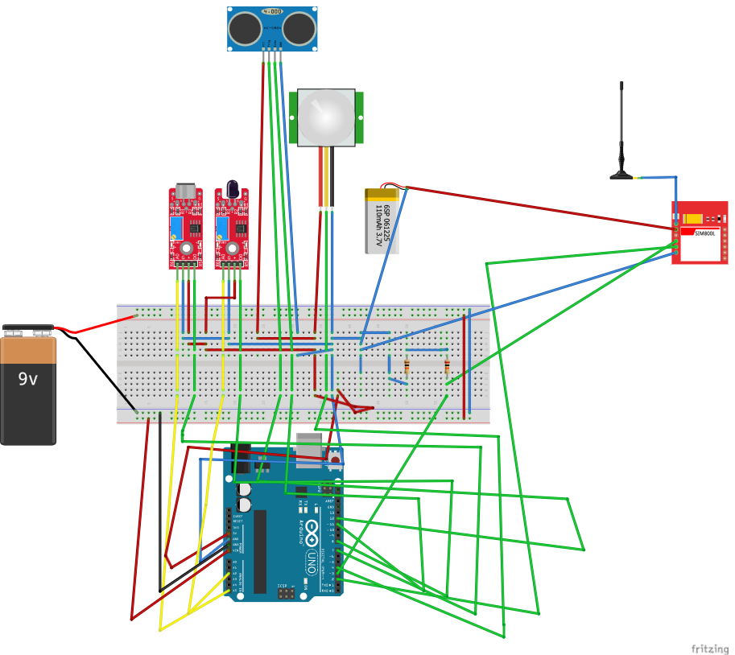
SCHEMATIC
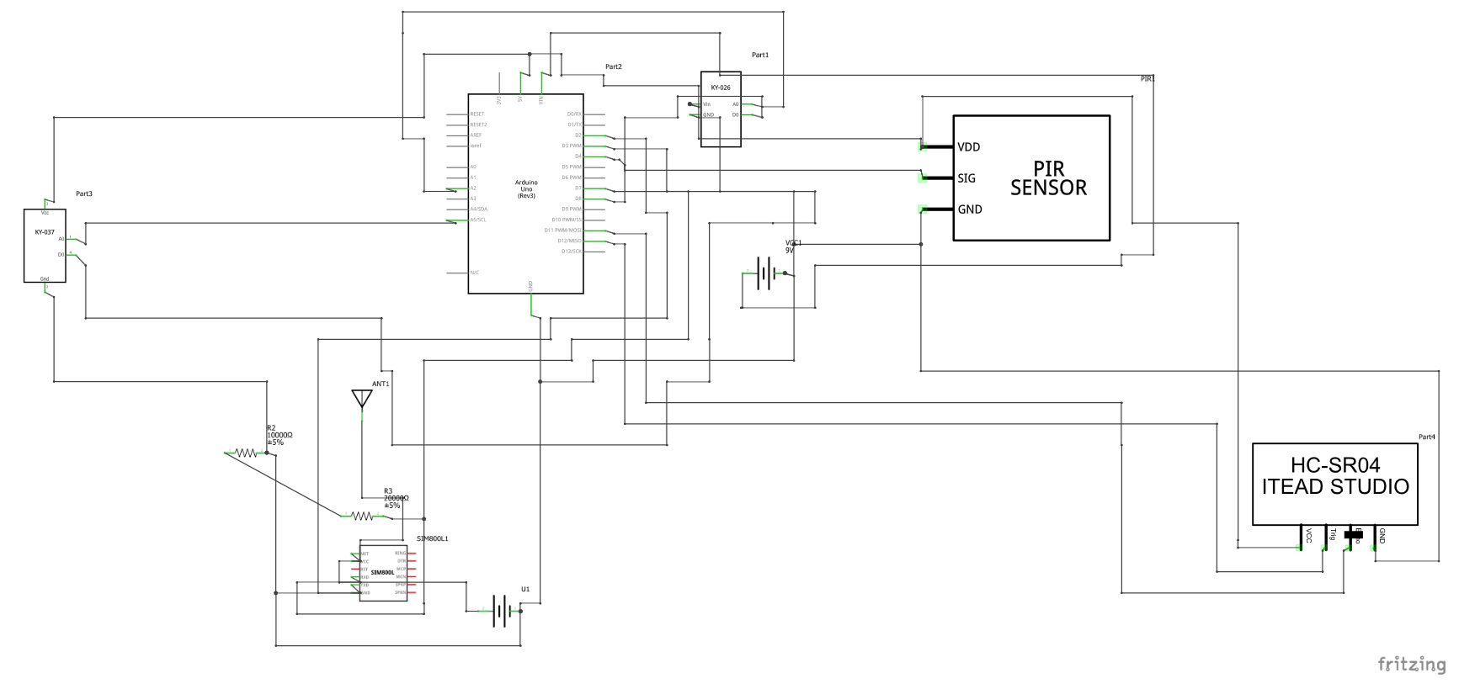

LIMITATIONS OF THE SYSTEM AND SOLUTIONS
- Thes system cannot differentiate between humans and animals and as a result, it will also flag animal movements as intrusion detected.
The solution to this limitation is adding a camera to the system and substituting the microcontroller board used with a more advanced one which supports computer vision artificial intelligence since it can differentiate one object from another.
Thus, the Arduino Board needs to be substituted with a Raspberry pi module
- The system cannot differentiate between sounds made by different objects, for instance, the system cannot differentiate between animal sounds, human sounds, and sounds from lumbering activities.
This can also be solved using an advanced microcontroller board.

CONCLUSION
The project demonstrates a basic solution to assist forest monitoring using affordable components. It serves as a prototype for future large-scale deployments.

